EE 40 Final Project Proposal

Charles Lee, Xinhe Ren

Thursday 2-5 pm lab

1. We will add a Bluetooth transceiver to an Arduino Uno in order to let the microcontroller to communicate to a laptop wirelessly. We can then control the robot with a Myo armband that steers the robot through laptop commands via Bluetooth. We can also add a potentiometer to change the speed of the robot.
2. A voltage follower is needed for the potentiometer. The potentiometer alters the voltage analog input into the microcontroller.

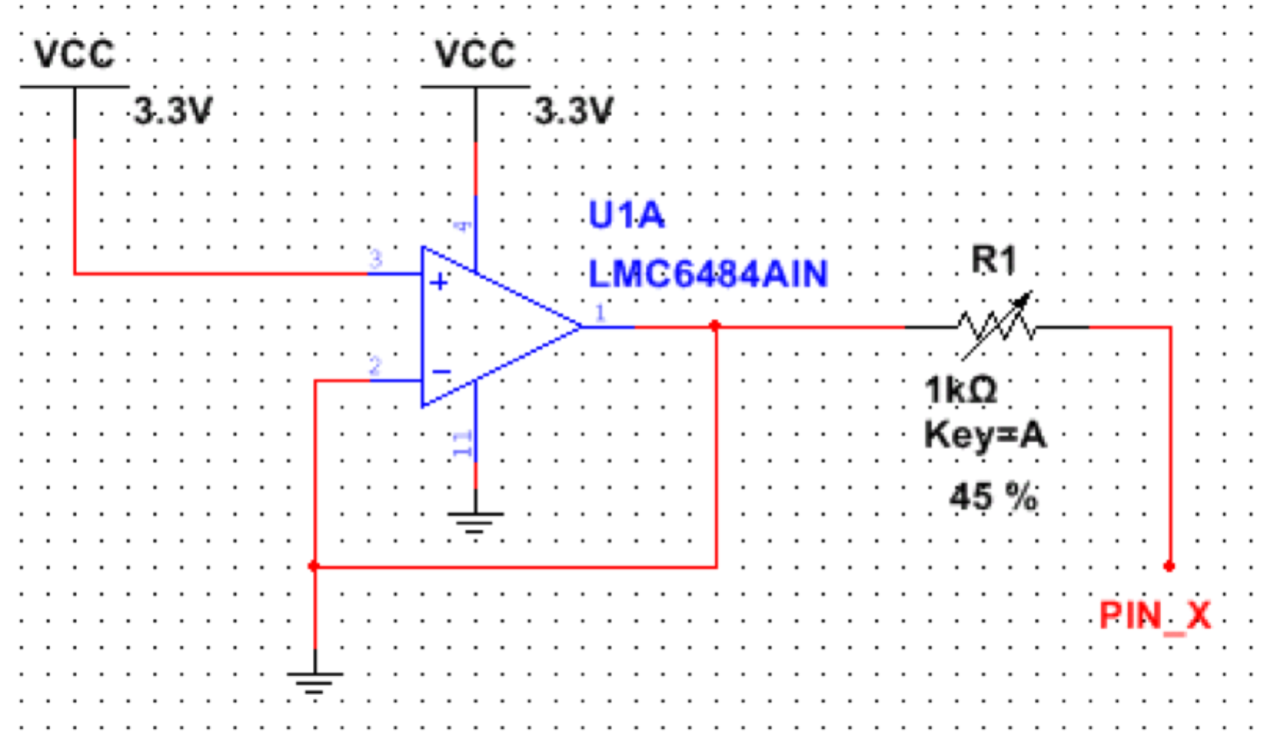

Shopping list:

* JY-MCU Arduino Bluetooth Wireless Serial Port Module ($9.99)

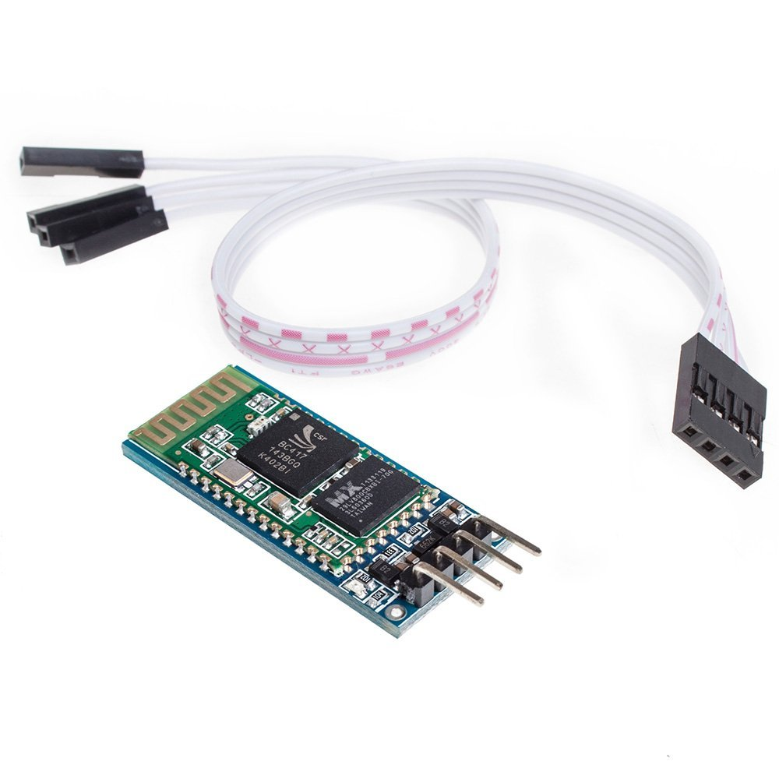

[Datasheet](http://www.ram-e-shop.com/ds/general/Bluetooth_TRx_Module_New.pdf)

[Amazon Link](http://www.amazon.com/gp/product/B0093XAV4U/ref=ox_sc_sfl_title_1?ie=UTF8&psc=1&smid=A2FSIHHQGP7DBY)

* Wheels (price unknown)